2023 ZX4RR ECU Removal tip sheet
(use at your own risk!, I am not responsible for any damage you do to your motorcycle while using this tip sheet)
Tools needed:
5mm Allen head wrench
4mm Allen head wrench
Medium size flat blade screw driver
This is your shiny new motorcycle. Take a breath and take your time. It should all go smooth and easy. If its not, take a step away and take a break.
Remove the back and front seats. The back seat removes with the key. There is a wire tucked away on the right side, front of the opening for the back seat. You pull that and it releases the front seat
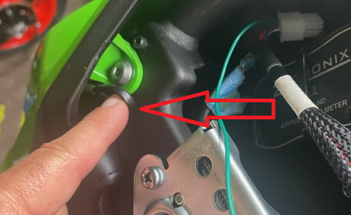
Remove 1 of the bolts holding on the mid fairings on each side. It is the black 4 mm Allen head in the middle of the black textured section of the mid fairing.
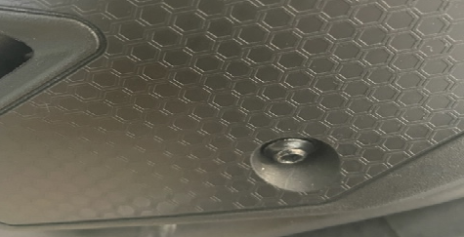
The rest of the back part of the mid fairing is held in by rubber posts into grommets. You can put your hands top and bottom of the rear portion of the mid fairing and pull straight out. You can now move the fairing up out the of way to remove the front 4mm allen head that holds the tail section on each side into place and screws into the aluminum block. Remove the bolt and be sure to catch the stepped washer behind it. ( note you will not have the corrugated looking wire that is on my bike, that is my wide band o2 sensor)
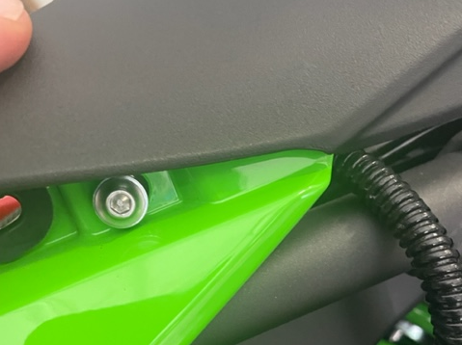
Remove 4 bolts 5mm Allen head bolts that hold the back of the tank down. Mine were a bit stubborn and my allen head didn’t fit well into them. Be careful not to round them out
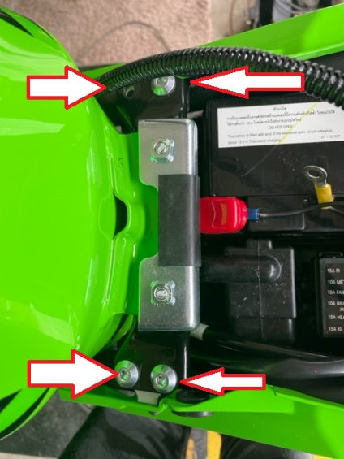
Unplug fuel pump. Push release tab and pull apart
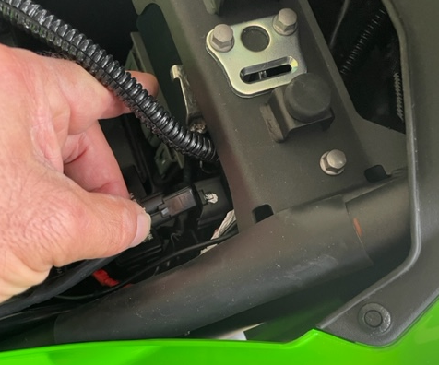
Remove the two vent lines from left hand side of the fuel tank
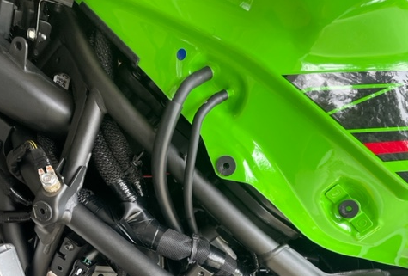

This is the only tricky part. The tank is now only held into place by two 2 tubes sliding into 2 rubber gromets but the fuel line is still connected. 2 sets of hands work best for this. Have someone lift the rear of the tank up. You will see the fuel line. Slide the medium size flat blade screw driver into the top of the connector from the side of the Rubber line opposite the metal pipe. Once it is in between the metal pipe and connector twist the screw driver to get the clip to pop up. Once the clip is in the up position or if it comes off you can pull the rubber fuel line off the metal line. This is what the connector will look like when it is in the up position and removed. Put it back like this when reinstalling the line and once you push the line bike over the metal line, lock it into place by pushing the lock clip down
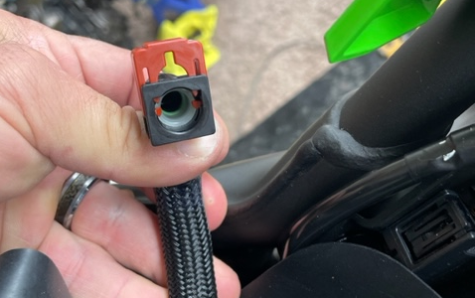

Lift the rear of the tank up and wiggle it backwards to free it from the rubber grommets. The tank is now free to lift up. Place it on a blanket or something soft. Make sure it is out of the way where no one will kick it or trip over it.

Here are the grommets. Apply a small amount of grease to them to ease reassembly and to make the next removal easier. It will also make the rubber last longer. I do the same for any of the rubber grommets that have things pushed into them. Using lube is being kind.
Your now looking at the ecu on the top of the airbox
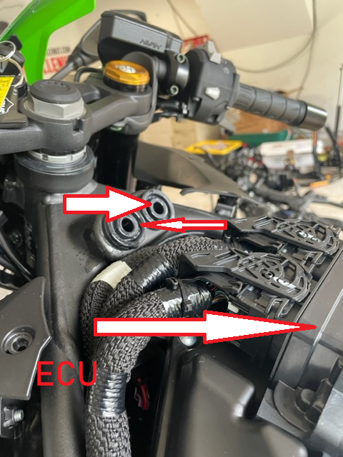
To free the ecu connectors , use the allen head and push on the release tab in the center and swing the lock bar out of the way and unplug the connector. Do this for both connectors and then you can lift the ecu straight up. Your done and now have the ecu in your hand! Get it sent in to Flashed by Vcyclenut to experience what your bike should perform like !! I hope this was helpful!
