2022 and up MT10 ECU REMOVAL
The new MT10 is a lot more work to remove the ecu but its still is not that bad. It is in the tail section and can be seen underneath the exup servo motor
Lets start by moving the exup servo out of the way. To do this remove the rubber band from the one side and lift the exup servo motor out of the way. You can leave it plugged in and just swing it forward
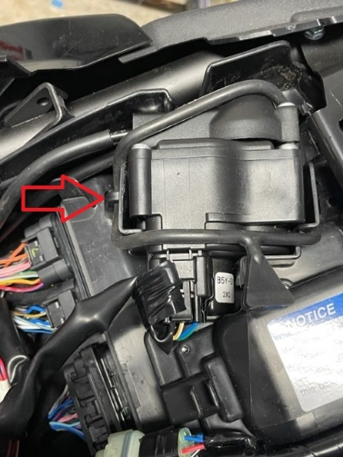
Now lets remove the center tail piece section. There are two bolts on top and two push pins un the underside. Remove these and the center piece will lift off by lifting it up and back. Please forgive my dirty bike!! The PNW tends to be a bit wet
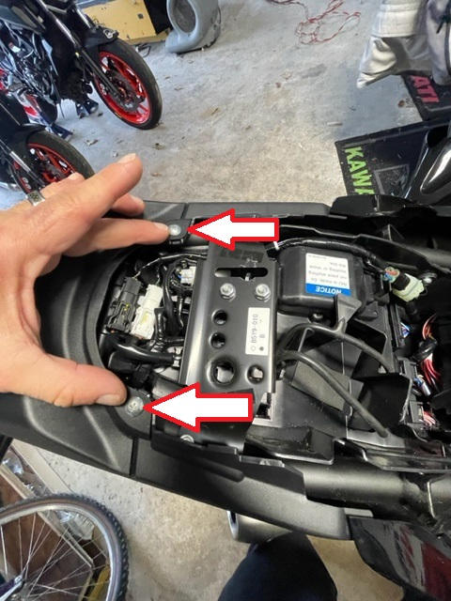
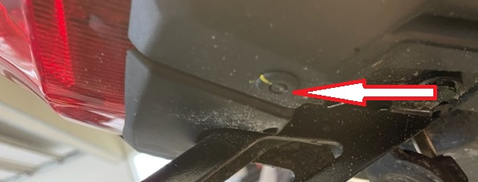

Now lets remove the side fairing pods. There are two bolts on both the front and back and two larger push pins on the bottom side. The push pins on the bottom side are in the recesses.
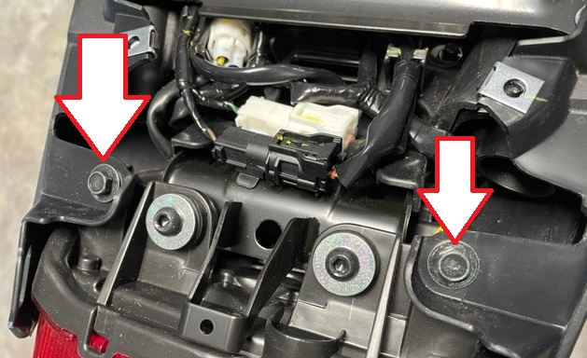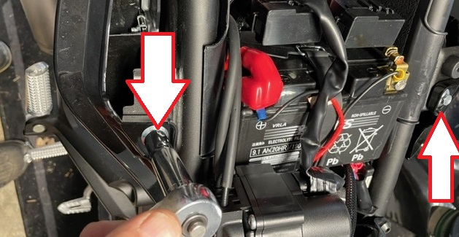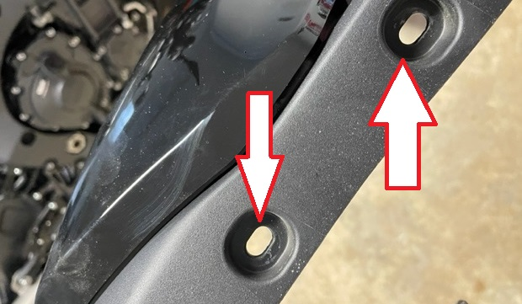
We have to remove the rear set locking mechanism. Remove the four bolts and lift it out of the way and set it aside.
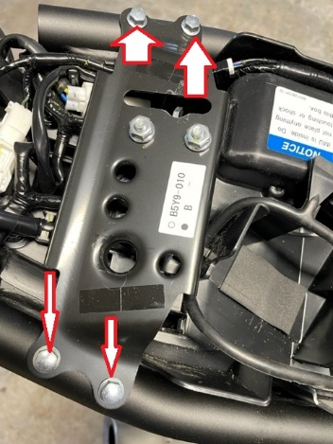
Now lets remove the bolts holding the tray down above the ecu. There are two phillip head screws on the bottom side. The two rear most nuts for the license plate holder. Two allen screws on each side of the tray. This will allow you to move the tail light out of the way and unplug what you need to so that the wires can be moved around so that the tray can be lifted up. I recommend using your cell phone to take pictures before you start unplugging and moving the wires around to aid in reassembly.
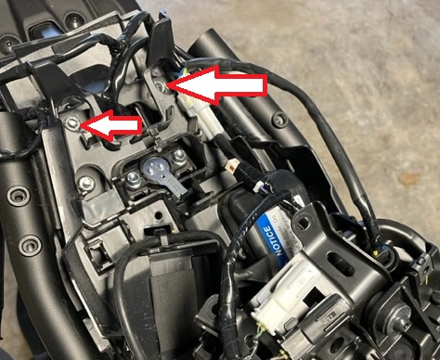
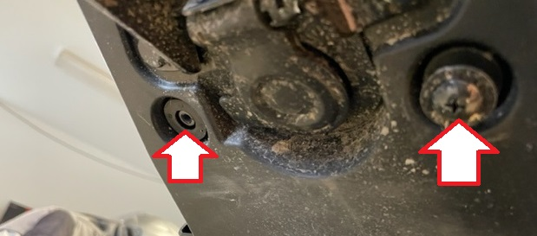
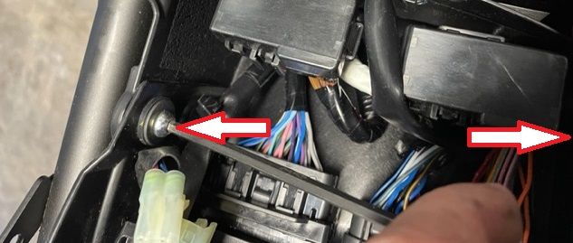
You can now lift the tray up out of the way
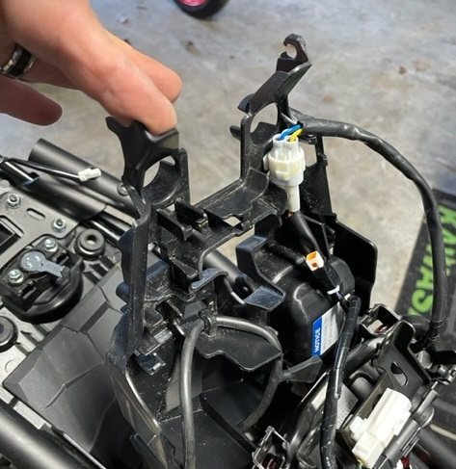

Under the tray you just lifted is the ecu. Unplug the ecu and remove it. The two smaller connectors you push the release tab and unplug that connector. On the larger one you push the release tab and swing the locking bar up and the connector will release. You are now holding your ecu to send to Flashed by Vcyclenut for the best flash in the business!!
