2022+ MT10 AIS BLOCK OFF PLATE INSTALL INSTRUCTIONS

Disclaimer: Work on your motorcycle at your own risk. I accept no responsibility for any issues or damage you do to your bike following these directions. These directions are only made as a guide to make the job easier.
Tools Needed:
Phillips screwdriver
8 and 10 mm socket
4 and 5 mm allen wrench
1) Remove the seat
2) Remove two push pins from center front tank cover. Push it down slightly to release, it will lift off.
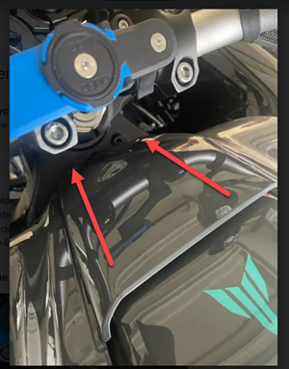
3) Remove left and right air scoop covers. They have 3 bolts that are easily visible. After removing the bolts I still stuggled a little to get them off. Grabing them from the underside and twisting them got them to release.
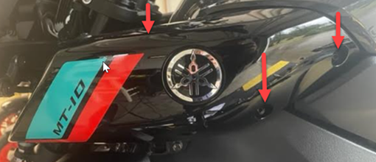
4) Remove left and right tank covers. There are 4 screws. After they are removed you can pull the cover straight out and the cover will come off. There is a post in a rubber grommet that the cover must be pulled off of.
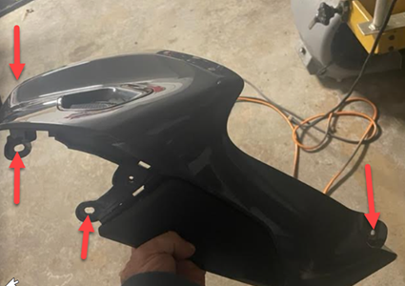

5) Remove the bolt from each side of the tank. Loosen but don’t remove the rear bolt. Get on left side of motorcycle lift tank up and remove two overflow lines. Move to right side of bike , lift tank, unplug fuel pump and remove fuel line. To release fuel line, use a small flat blade screwdriver and pull lock tab down. Fuel line will pull straight off. When reinstalling fuel line after placing line back on push lock tab back in. Remove rear tank mounting bolt and lift tank off.
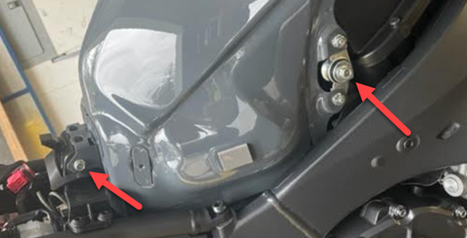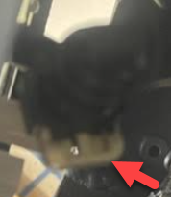

6) Remove snorkel from each side of the air box. There is one screw on the left one and two screws on the right one. Remove screws and they just pull straight out from the airbox

7) Remove air box lid. There are several screws around the parameter, a sensor in the top right corner and two items secured on each lower corner. Remove them and lift lid off.

8) Remove air box base . Remove crankcase ventilation line from rear middle, remove ais line from left underside, remove bolt from front center and lossen 6 bolts from velocity stocks. The bolts in the velocity stacks are captive and will not come out. Once everything is loose the base will easily lift off. If you do not want to do all the work of installing the block off plates but still want to eliminate popping on decel, you can plug off the ais line with a marble and reinstall everything.
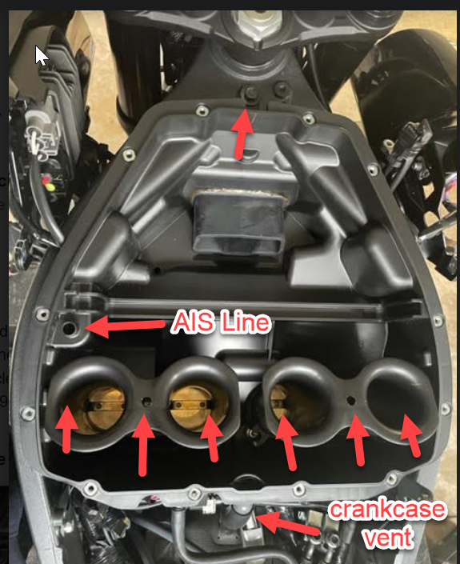
9) Now your looking at this mess. Unplug all the sensors and put loose wires up into the open area in frame. Unbolt two sensors and lay them there loose. Remove the push pins and screws to loosen the plastic plate until you can lift it and move it out of the way.
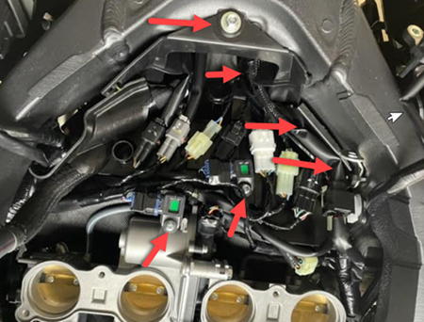
10) You can now see the AIS system. Remove 2 bolts from each ais cover. They have loctite on them. Unplug the ais solenoid and temporarily remove the ais system from the bike. On the 22 and up bike even If I am flashing your ecu the ais solenoid can not be removed. To keep crusie control functional remove all vacuum lines from the solenoid and after installing the plates put the solenoid back on the bike with it plugged into the harness.
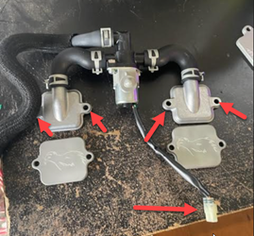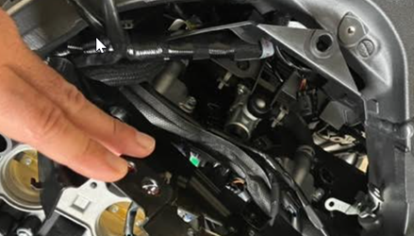
11) Leave the reed valve plates on the bike. They have a rubber gasket on them that will act as a seal. My plates are milled out on the underside to fit over the reed valve plate. Put block off plates on bike where covers were. I find cleaning the bolts off with a wire brush to remove any loctite makes them easier to install. Tighten bolts to factory torque specs.
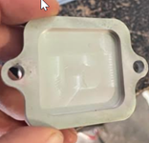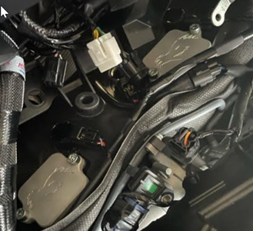

12) Cap off AIS port on airbox base and put the motorcycle back together.
