Heated grip install
I am not an engineer, install heated grips at your own risk. I am not responsible for any damage to you or your bike while performing this installation. This is meant as a guide only.

I purchased replacement Oxford heated sports grips for both sides, $40 total
I had a set of old 3 wire turn signals laying around that I stole the wires from but they can be had for $15 on flea bay
I used pro taper grip glue , use what you prefer for securing the new grips

The oxford grips have a square connector that will not plug into the factory heated grip plugs. Cut them off flush. I had 3 wire turn signals but the heated grips use 2 wires. I plugged them in to see what wire was not needed and cut it off flush at the connector. I left the remaining turn signal wires about 8 inches long. I stripped the wires back and soldered the connectors together. I used shrink tubing to cover the connections. There should be no polarity on heated grips but I did keep the colors I connected the same on both grips. Red to brown, white to blue
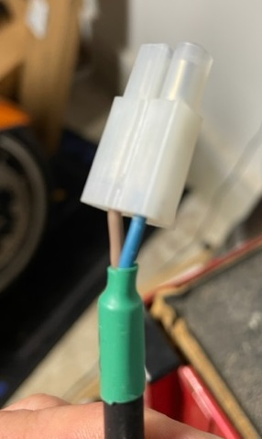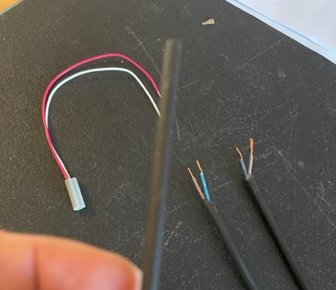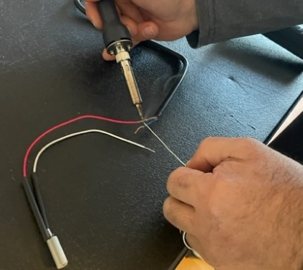
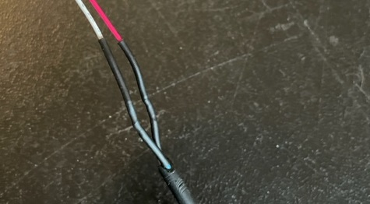
Next access the factory heated grip plugs. They are located behind the dash under the windshield. Remove the screws holding the shield on and the screws holding the bracket it bolts to. Your looking at this. This last cover just snaps into place. Lift it straight up and it will come off.
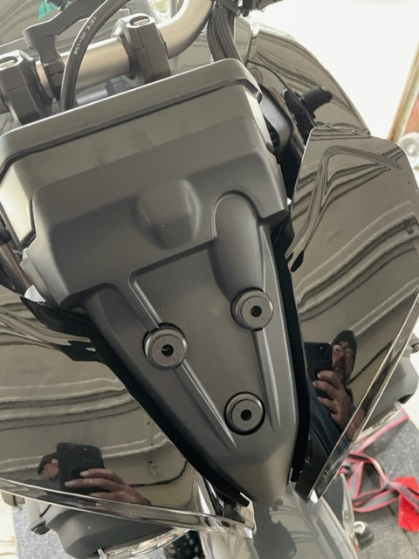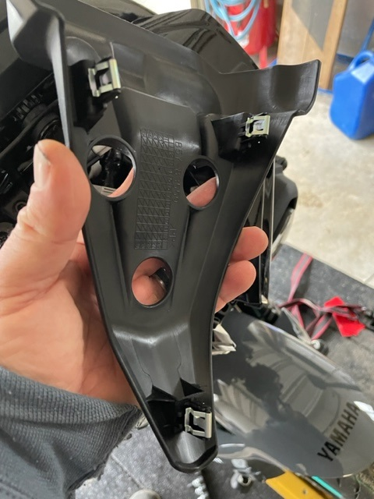

Now you are looking at the connectors. They are tapped together. Carefully cut the tape so they are separated. This picture shows them plugged into the heated grips. First we need to properly run the wires
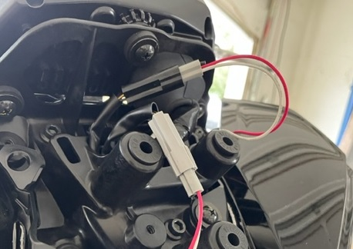

Remove the bar ends. I cut the factory grips off with a razor blade and removed any glue stuck to the bar and throttle tube. Cover the tank and intake scoops with a towel to catch any excess glue. Liberally apply grip glue to the bar and grip and twist them on. Make sure the wires don’t interfere with pulling in the clutch on the clutch side and be mindful you will be twisting the throttle on the throttle side. Situate the wires appropriately. On each side I was able to run the wires with the existing wire holders without any additional zip ties. I followed the factory wire bundle to the underneath of the gauge cluster. There are gaps in the front area where the plugs are to run the new wires through. Double check you have enough slack on the throttle side. Plug them into the factory connectors and position them so the cover can snap back into place and reassemble everything.
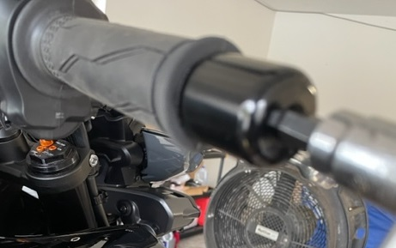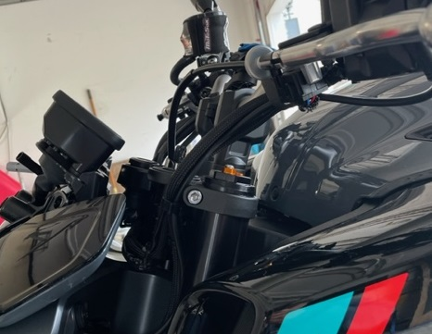

Turn the key on and your new heated grips are controlled on the dash with the thumbwheel. You can see the icon in the bottom right corner.
