First remove the seat by inserting the key under the seat, turning the key and lifting seat at the same time. Put the seat in a safe place.
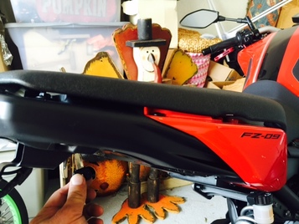
Remove the one bolt from each faux air scoop
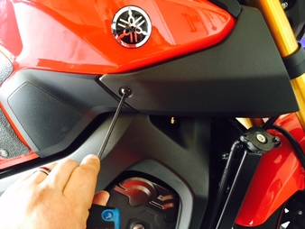
Remove 2 plastic push pins from plastic cover at front of the tank, by pushing center portion till it clicks inward and pin will pull out

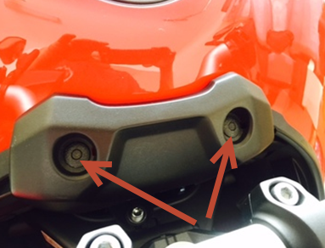
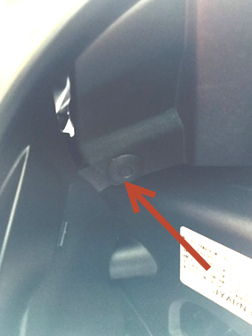
Remove 2 plastic push pins from the front portion, back side of each faux air scoop. After removal air scoops will pull off the bike. Grab from front and back edge and pull straight out.

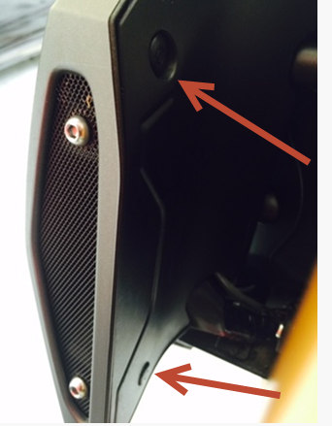
Place tape on frame like pictured to protect during reassembly and remove bolt from each side of tank.
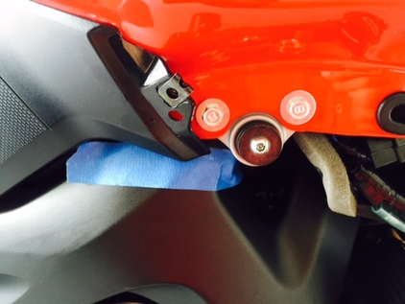
Remove 2 bolts from rear of the tank
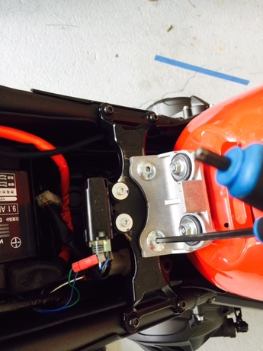
Move two rubber trim pieces from front of the tank out of the way by swinging them up.
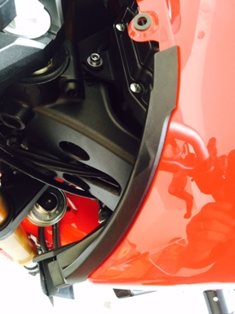 | 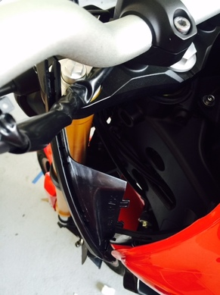
Tank is now ready to lift up. Grab on rear handle and front edge. Lift straight up slightly, move rearward enough to clear bars and lift front of the tank. Prop rear bracket of tank against tip over sensor bracket. It will hold it steady in place. This will allow you to hold the tank with your left hand and use your right hand to unplug the two vent lines from under the tank, the fuel line and the wiring to the fuel pump. To remove the fuel line slide the plastic guard back and squeeze the connector from both sides
 | 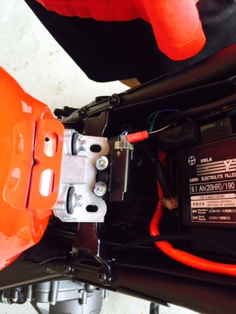 | 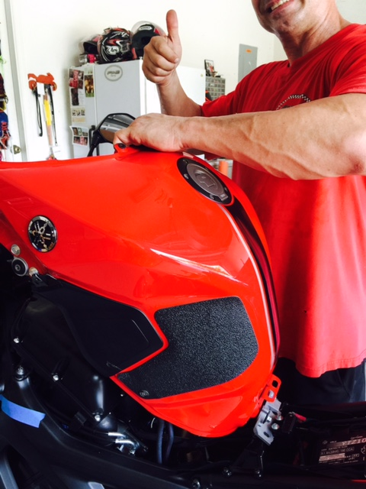

Now that the tank is off you will be looking at the top of the airbox. Unplug and remove the ECU. If it’s the first time removing the ECU it may be a bit stuck. Stick a flat blade screwdriver behind it and use it to pop it free, it should then slide right out. Remove the three bolts holding the air box down and loosen the three clamps on the throttle bodies. . There are two vacuum lines on the underside of the air box that will need to be removed also. Remove the air box
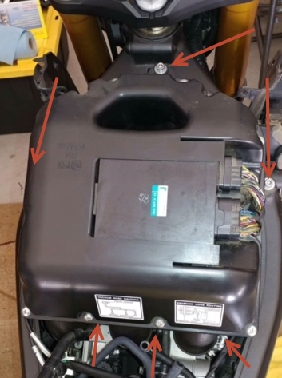

You should now be looking at something like this. I place rags into the intake ports to avoid an accidental drop of a screw or something similar into the tract. I have an arrow pointing to the plug for the AIS solenoid. If you have an UNFLASHED 2017 fz09 or UNFLASHED XSR900 you will need to leave this solenoid plugged in, otherwise unplug it. Use the zip tie to secure it to another wire.

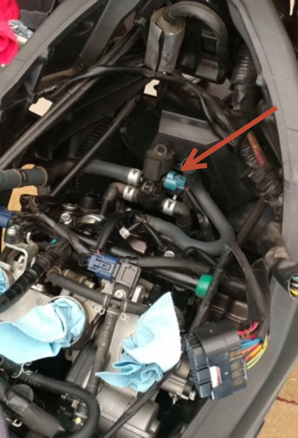
Follow the vacuum lines from AIS solenoid to the plates on top of the valve cover. Remove the clamps holding the vacuum lines to the plates, remove both vacuum lines and the entire assembly will lift out.
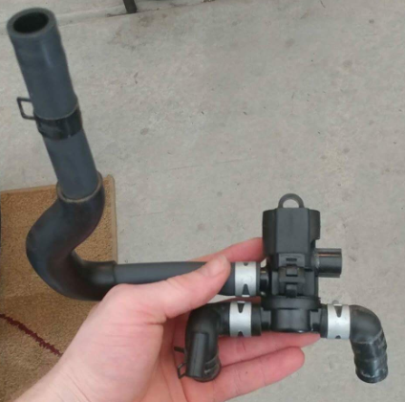
Picture show what you now have. To get a better picture I removed the crankcase ventilation line DO NOT REMOVE THIS LINE.

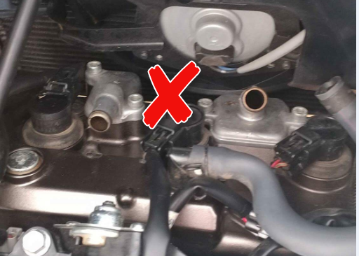

Remove the four screws holding the stock plates down. They have Loctite on them and can be hard to remove. Loosening the radiator mount to move it a bit may help access. 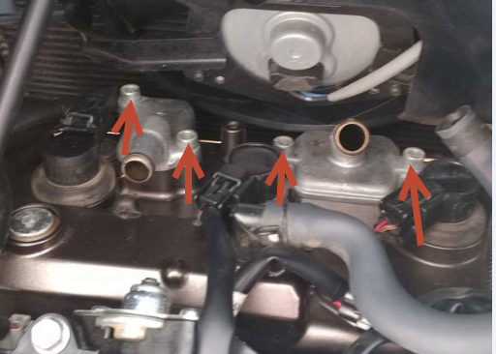
Lift off the two covers. Leaving the reed valve plate in place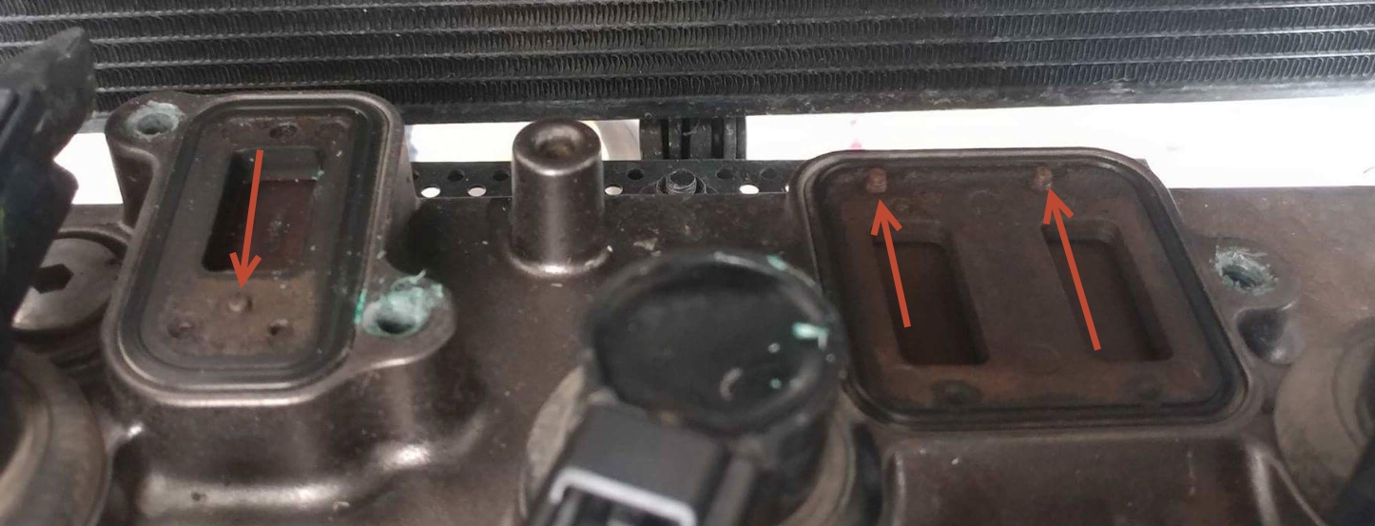

There are raised dimples on the plates. The machined recess on the bottom of the block off plates must go over these dimples or they will keep the plates from sealing and leak badly.

Reinsert the factory bolts and tighten to factory spec (7.2 Ft/lbs) 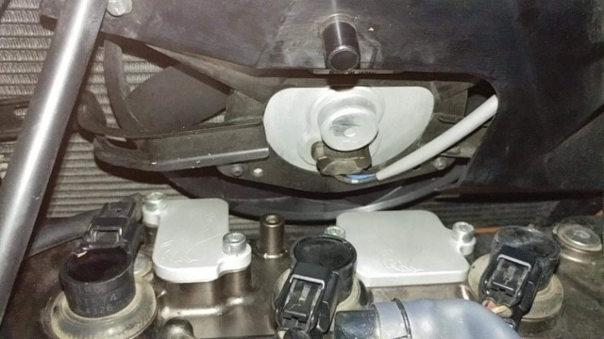

Use the supplied vacuum cap to block off the port on the underside of the air box that the AIS line attached to. It will fit snuggly and does not require any type of clamp but you can use the factory hose clamp if desired.
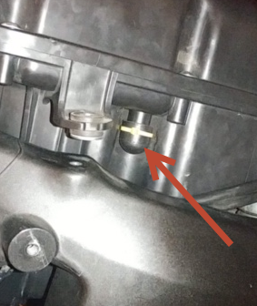

Plug in the crank case ventilation line to the underside of the air box and install air box back on bike. Make sure the intakes slide fully over the throttle bodies and that the hose clamps are in their indexed position. Reinstall everything in reverse direction. Take care that the fuel line is routed correctly or it can kink and cause fuel starvation problems under heavy load.

