2021 MT09 ECU Removal Instructions

Remove 4 allen screws and 4 push pins holding on air scoop covers and plastic air intake assembly. The covers will pull straight off after removing 2 screws and 2 pins and then plastic assembly will be easy to remove after removing remaining two screws and 2 pins

Place tape under front mounting screws for tank to protect the frame and remove the two allen bolts. One on each side
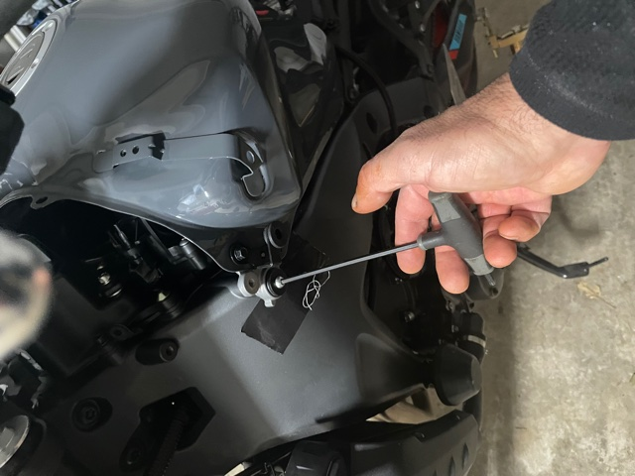
On back of tank remove 2 black screws closest to the tank and loosen the 2 screws furthest away from tank so that it gives you play to lift front of tank up 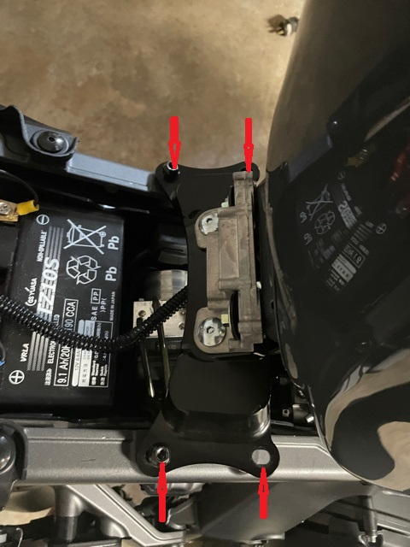

If this is the first time removing ecu it will stick to the airbox lid. While holding tank up as shown use flat blade screwdriver to pop ecu loose from top edge. Insert screwdriver at edge shown with arrow
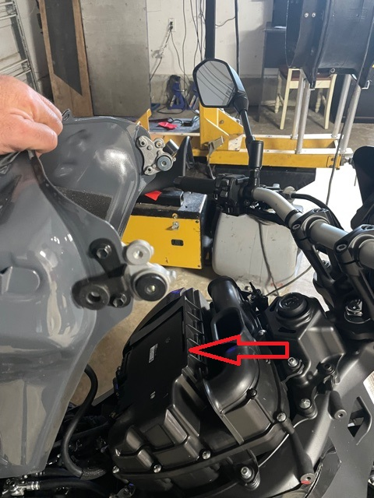

If you have help you can have someone hold the tank up while you pull ecu out of air box lid and unplug the ecu. If by yourself pull ecu out of airbox lid and let hang between frame and tank from the left side

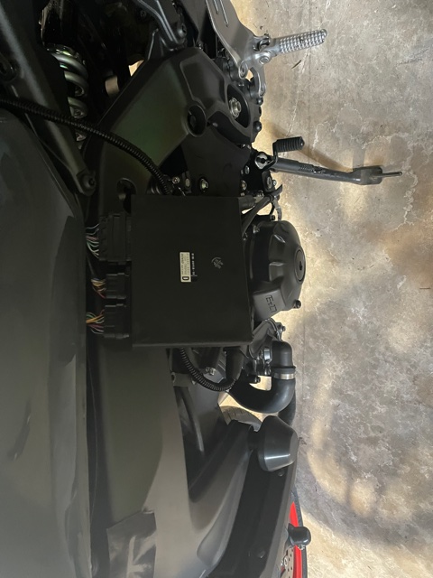

To unplug the two small connectors. Push on release tab in center and pull gently on connector. If you have to use force, you have not released it with the tab. For the larger connector push down on center tab and swing lock bar up and it will release
